**Project Planning Phase**

**Project Planning Template (Product Backlog, Sprint Planning, Stories, Story points)**

|  |  |
| --- | --- |
| Date | 26 june 2025 |
| Team ID | LTVIP2025TMID32104 |
| Project Name | sustainable smart city assistant using ibm granite llm |
| Maximum Marks | 5 Marks |

**Product Backlog, Sprint Schedule, and Estimation (4 Marks)**

|  |  |  |  |  |  |  |
| --- | --- | --- | --- | --- | --- | --- |
| Sprint | Epic | User Story Number | User Story / Task | Story Points | Priority | Team Members |
| Sprint-1 | Project Initialization | USN-1 | Set up Streamlit interface with modular navigation and base layout | 2 | High | All |
| Sprint-1 | Watsonx + Pinecone Integration | USN-2 | Configure environment (.env) and test IBM Granite LLM + Pinecone connectivity | 3 | High | Hemanth |
| Sprint-2 | Policy Summarization Module | USN-3 | Upload .txt/.csv policy files and generate AI summaries | 4 | High | Bhargavi |
| Sprint-2 | Semantic Search Module | USN-4 | Implement Pinecone-based semantic document search | 3 | Medium | Santhosh Mani |
| Sprint-3 | Eco Tips + Chat Assistant | USN-5 | Build keyword-based eco tips and sustainability chat assistant | 4 | High | Jaya Prakash |
| Sprint-3 | KPI Forecasting | USN-6 | Forecast future KPI trends from uploaded CSV files using ML | 4 | Medium | Hemanth |
| Sprint-4 | Anomaly Detection | USN-7 | Analyze uploaded data and flag anomalies in utility metrics | 3 | High | Bhargavi |
| Sprint-4 | UI Finalization + Deployment | USN-8 | Polish UI (cards, sidebars, toasts) and deploy app | 4 | High | All |

**Project Tracker, Velocity & Burndown Chart: (4 Marks)**

|  |  |  |  |  |  |
| --- | --- | --- | --- | --- | --- |
| Sprint | Total Story Points | Sprint Start Date | Sprint End Date | Story Points Completed | Sprint Release Date |
| Sprint-1 | 4 | 12 June 2025 | 15 June 2025 | 4 | 15 june 2025 |
| Sprint-2 | 7 | 16 June 2025 | 19 June 2025 | 7 | 19 june 2025 |
| Sprint-3 | 8 | 20 June 2025 | 24 June 2025 | 7 | 24 June 2025 |
| Sprint-4 | 7 | 25 June 2025 | 26 June 2025 | 6 | 26 June 2025 |

Average Velocity = (4 + 7 + 7 + 6) / 4 = 6 story points per sprint

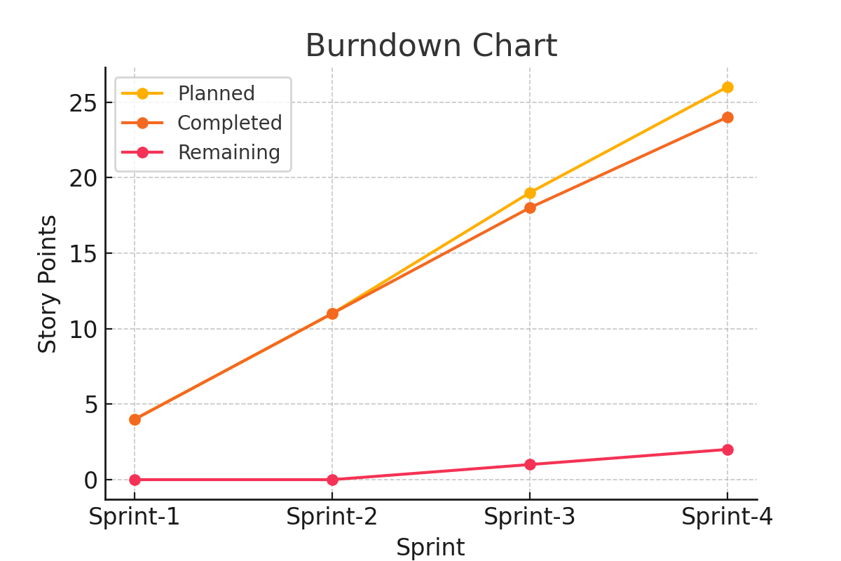

Figure: Sprint-wise Burndown Chart